**EVIDENCE OF MY SOCIAL MEDIA EXISTENCE**

**WHATSAPP**

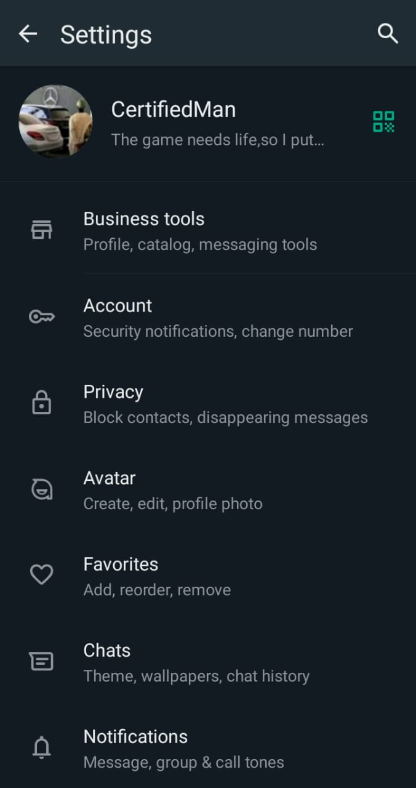

**INSTAGRAM**

